# Current Timestamp Functions - Exercise

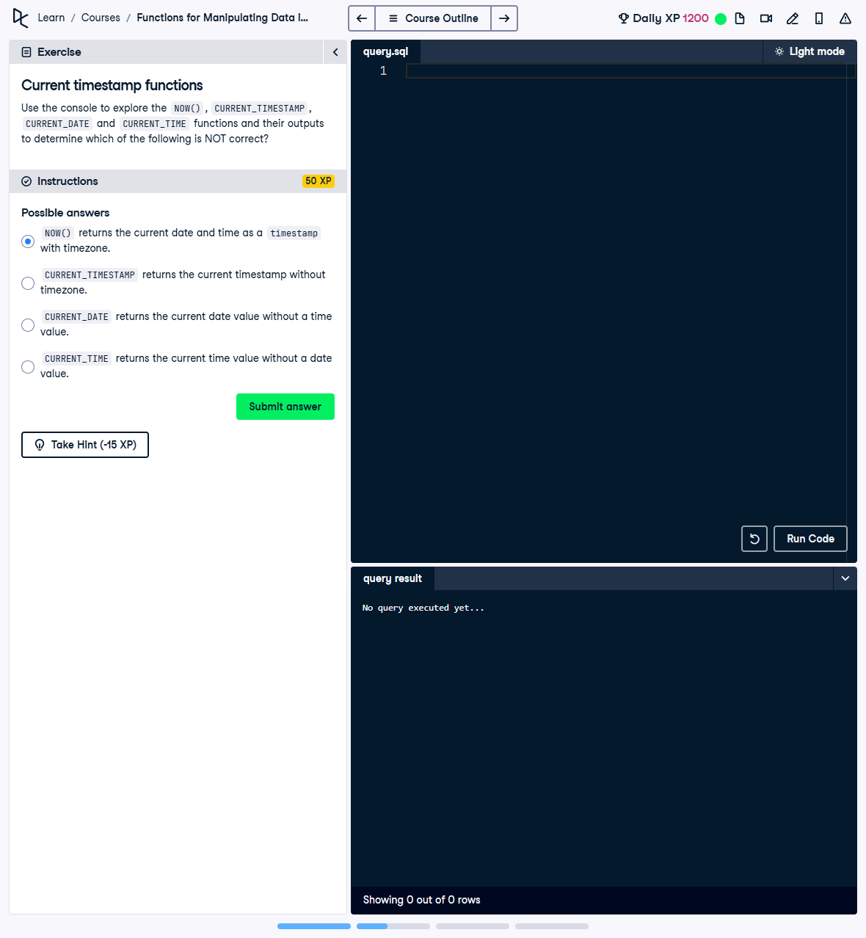

Question:

Use the console to explore the NOW(), CURRENT_TIMESTAMP, CURRENT_DATE, and CURRENT_TIME functions and their outputs to determine which of the following is NOT correct:  
  
1. NOW() returns the current date and time as a timestamp with timezone.  
2. CURRENT_TIMESTAMP returns the current timestamp without timezone.  
3. CURRENT_DATE returns the current date value without a time value.  
4. CURRENT_TIME returns the current time value without a date value.

## Answer:

Correct Answer: 2. CURRENT_TIMESTAMP returns the current timestamp without timezone.

## Explanation:

1. NOW(): This function returns the current date and time, including the timezone information. This statement is correct.  
2. CURRENT_TIMESTAMP: This function returns the current date and time as a timestamp with timezone. The statement is incorrect because it incorrectly claims it does not include timezone information.  
3. CURRENT_DATE: This function returns only the current date without any time component. This statement is correct.  
4. CURRENT_TIME: This function returns only the current time without any date component. This statement is correct.